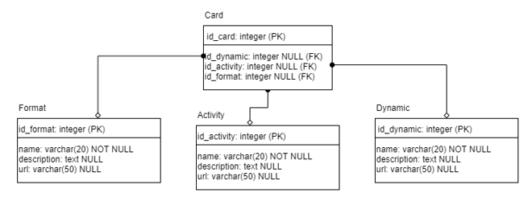

Рис 1.1 – ER – диаграмма

Таблица 1 – Поля таблицы Card

|  |  |  |
| --- | --- | --- |
| Название | Тип данных | Доп. Парметры |
| id_card | integer | Primary Key |
| id_dynamic | integer | NULL, Foreign Key |
| id_activity | integer | NULL, Foreign Key |
| id_format | integer | NULL, Foreign Key |

Таблица 2 – Поля таблицы Format

|  |  |  |
| --- | --- | --- |
| Название | Тип данных | Доп. Парметры |
| id_format | integer | Primary Key |
| name | varchar(20) | NOT NULL |
| description | text | NULL |
| url | varchar(50) | NULL |

Таблица 3 – Поля таблицы Activity

|  |  |  |
| --- | --- | --- |
| Название | Тип данных | Доп. Парметры |
| id_activity | integer | Primary Key |
| name | varchar(20) | NOT NULL |
| description | text | NULL |
| url | varchar(50) | NULL |

Таблица 4 – Поля таблицы Dynamic

|  |  |  |
| --- | --- | --- |
| Название | Тип данных | Доп. Парметры |
| id_dynamic | integer | Primary Key |
| name | varchar(20) | NOT NULL |
| description | text | NULL |
| url | varchar(50) | NULL |

Таблица 5 – Записи в таблице Card

|  |  |  |  |
| --- | --- | --- | --- |
| id_card | id_dynamic | id_activity | id_format |
| 1 |  | 2 | 3 |
| 2 | 2 | 3 |  |
| 3 | 4 | 4 | 4 |
| 4 | 1 |  | 2 |
| 5 | 5 | 1 | 2 |

Таблица 6 – Записи в таблице Dynamic

|  |  |  |  |
| --- | --- | --- | --- |
| id_dynamic | name | description | url |
| 1 | Some dynamic 1 |  |  |
| 2 | Some dynamic 2 | Just some description |  |
| 3 | Some dynamic 3 |  |  |
| 4 | Some dynamic 4 |  |  |
| 5 | Some dynamic 5 |  | Example.com/dynamic/1 |

Таблица 7 – Записи в таблице Dynamic

|  |  |  |  |
| --- | --- | --- | --- |
| id_activity | name | description | url |
| 1 | Some activity 1 |  | example.com/activity/1 |
| 2 | Some activity 2 | Description |  |
| 3 | Some activity 3 |  |  |
| 4 | Some activity 4 | Just some text | example.com/ activity/2 |
| 5 | Some activity 5 |  |  |

Таблица 8 – Записи в таблице Format

|  |  |  |  |
| --- | --- | --- | --- |
| id_format | name | description | url |
| 1 | Some format 1 | Some description |  |
| 2 | Some format 2 |  | example.com/format/1 |
| 3 | Some format 3 | Other description |  |
| 4 | Some format 4 |  |  |
| 5 | Some format 5 |  |  |